McDonald’s x Crocs
McDonald’s and Crocs are dropping an epic collab in New Zealand, designed for next-level Fandom
Consumers in New Zealand can step into the world of McDonald’s x Crocs, starting 8 November 2023

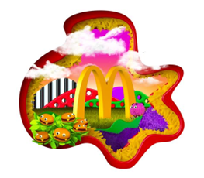

McDonald’s and Crocs fans are about to elevate their look courtesy of McDonald’s x Crocs first-ever collab in New Zealand. The brand mashup is inspired by both Crocs Stars™ and Macca’s loyalists and will drop with a full line of shoes and Jibbitz™ charms beginning 8th November in more than 30 countries around the world, including New Zealand.

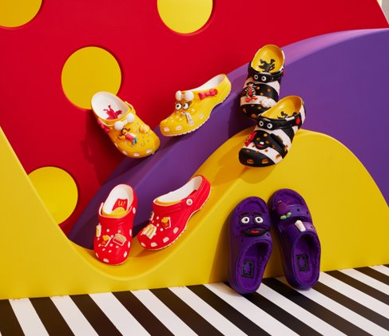

From a Classic Clog with a McDonald’s spin to a throwback, limited-edition collection inspired by iconic McDonald’s characters – Grimace, Birdie and Hamburglar – the new shoes are designed to give consumers a way to live out their unapologetically bold fandom every day.
The Crocs are being sold in New Zealand exclusively through Platypus and an in-restaurant pop up store.

The “Croc thru” will be in residence at McDonald’s Britomart from 9am Wednesday 8th November, selling the shoes for just three days and allowing you to get fries with that. Across Wednesday, Thursday and Friday Crocs and Macca’s fanatics can pick up a pair from the limited stock between 9.00am and 7pm.

For fans further afield, Platypus has the whole range available in store and online at www.platypusshoes.co.nz/shop/crocs. Follow along on social at @McDonaldsNZ and @CrocsNewZealand to keep tabs on when the Crocs go on sale.

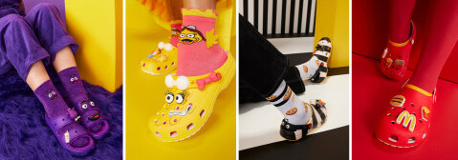

The full McDonald’s x Crocs Collection includes a line of shoes with Jibbitz™ charms available for between $149.99 – $159.99 a pair,
- Grimace x Crocs Cozzzy Sandal: Inspired by everyone’s purple bestie, these sandals lined in faux fur will have you feeling like you’re walking a day in Grimace’s shoes. The Grimace Cozzzy Sandal features his loveable expression on the straps, comes with his favorite treat – a shake in the form of a Jibbitz™ charm.
- Birdie x Crocs Classic Clog: Early birds like Birdie will be the first to get these Classic Clogs in her signature yellow and pink, with her favorite menu item – a McDonald’s Egg McMuffin – as a Jibbitz™ charm.
- Hamburglar x Crocs Classic Clog: Feel as stealthy as the Hamburglar himself with these Classic Clogs in the Hamburglar’s famous black and white stripes and Jibbitz™ charms featuring his go-to order (a hamburger, of course).
- McDonald’s x Crocs Classic Clog: For those who want to sport Crocs in a classic McDonald’s style, the McDonald’s x Crocs Classic Clog is for you. The best part? With new Chicken McNuggets, World Famous Fries and Big Mac Jibbitz™ charms, you can wear your go-to order everywhere you go.

[Photo caption] A few Crocs-loving Crew – who are also McDonald’s superfans themselves – can be found modeling ‘fits inspired by the collab.

“We’re constantly blown away by the way our fans show off their love for McDonald’s, and as it turns out, Crocs’ fanbase is just as passionate,” said Luke Rive, Director of Marketing at McDonald’s New Zealand. “We’re excited to team up with Crocs – another brand that’s deeply embedded in culture – on our first-ever global shoe collab that absolutely fuels the shared brand love.”

“Like McDonald’s beloved characters, Crocs are a part of many of our consumers’ earliest and often most memorable moments. Together, we’re bringing that nostalgia to new generations with experiences around the world that are as bold and audacious as our fans!”

Don’t forget to mark your calendars for Wednesday 8th November to get the limited-edition McDonald’s x Crocs collection while it’s hot.

For imagery, please click here.

ENDS

For media enquiries, please contact:
Jaimee Sewell | Senior Account Manager | Mango Communications
jaimees@thisismango.co.nz | 027 444 2166

About McDonald's
McDonald’s is the world’s leading global foodservice retailer with over 40,000 locations in over 100 countries. Approximately 95% of McDonald’s restaurants worldwide are owned and operated by independent local business owners.

About Crocs, Inc.
Crocs, Inc, headquartered in Broomfield, Colorado, is a world leader in innovative casual footwear for all, combining comfort and style with a value that consumers know and love. The Company's brands include Crocs and HEYDUDE, and its products are sold in more than 85 countries through wholesale and direct-to-consumer channels. For more information on Crocs, Inc. visit investors.crocs.com. To learn more about our brands, visit www.crocs.com or www.heydude.com. Individuals can also visit https://investors.crocs.com/news-and-events/ and follow both Crocs and HEYDUDE on their social platforms.

