**MEDIA RELEASE**

June 2024

**Macca’s shopping list tops $500 million in 2023**

McDonald’s shopping list looks a bit like the average Kiwis weekly shopping basket, just with a few more zeros added to the quantities and price. With around 90% of its ingredients sourced locally, Macca’s spent an eye-watering $218 million in 2023 with local suppliers to make your favourite burgers, sides, desserts, and breakfast items. A further $328 million of produce was exported to other McDonald’s markets, bringing the total spend with Kiwi producers to $546 million.

All the pantry and fridge essentials are there – eggs, milk, bread, fruit and veg, and the proteins. Even some of the supplier names will be familiar thanks to Macca’s long-term partnerships with local producers, growers, and businesses.

Here's a breakdown of exactly what $218 million actually buys:

* 7.1  million litres of milk was sourced from dairy farmers through Fonterra - enough to fill nearly 116 standard-sized swimming pools
* Almost 19 million kilograms of potato products were purchased and consumed locally in 2023 (we love our fries), the equivalent average weight of 9789 Tesla Y Models
* Over 107 million units of buns, muffins, rolls, and bagels were purchased from ARYTZA in Wairau Valley, which is enough to stretch 8,916 times across the Auckland Harbour Bridge
* 11 million free-range eggs were used last year, sourced from Otaika Valley and Zeagold Farms, that’s the equivalent weight of 4.5 male Blue Whales (the largest animal on earth)
* 1.7 million kilograms of cheese and other dairy products were produced by Fonterra for local restaurants, which equates to the weight of 100 transport busses
* 6.6 million kilograms was used locally for Macca’s 100 percent beef patties.

From harvesting tomatoes in the perfect horticultural soil of Pukekohe to the special varieties of potatoes grown just for Macca’s famous fries in South Canterbury, and handpicking Granny Smith apples from Hawke’s Bay and Nelson for delicious apple pies, suppliers around Aotearoa help Macca’s serve over 1.6 mill people each week.

“We take pride in offering our customers a menu where as many ingredients as we can are sourced locally,” says Managing Director NZ and Pacific Islands, Kylie Freeland. “At Macca’s we talk about the ‘three-legged stool’ of the corporate, our franchisees and suppliers. It’s a key strength of our business, and many of our supplier relationships go right back to when we first opened in New Zealand in 1976.”

Did you know Macca’s 100 percent beef patties are made by ANZCO Foods in Waitara from quality beef sourced primarily from farms across the central North Island? Kiwi-grown produce is also sent to McDonald’s markets including Australia, the Pacific Islands, Asia, and the United States. Last year a total of 37 million kilograms of beef was exported globally to other McDonald’s markets – that’s around 10 percent of New Zealand’s beef exports.

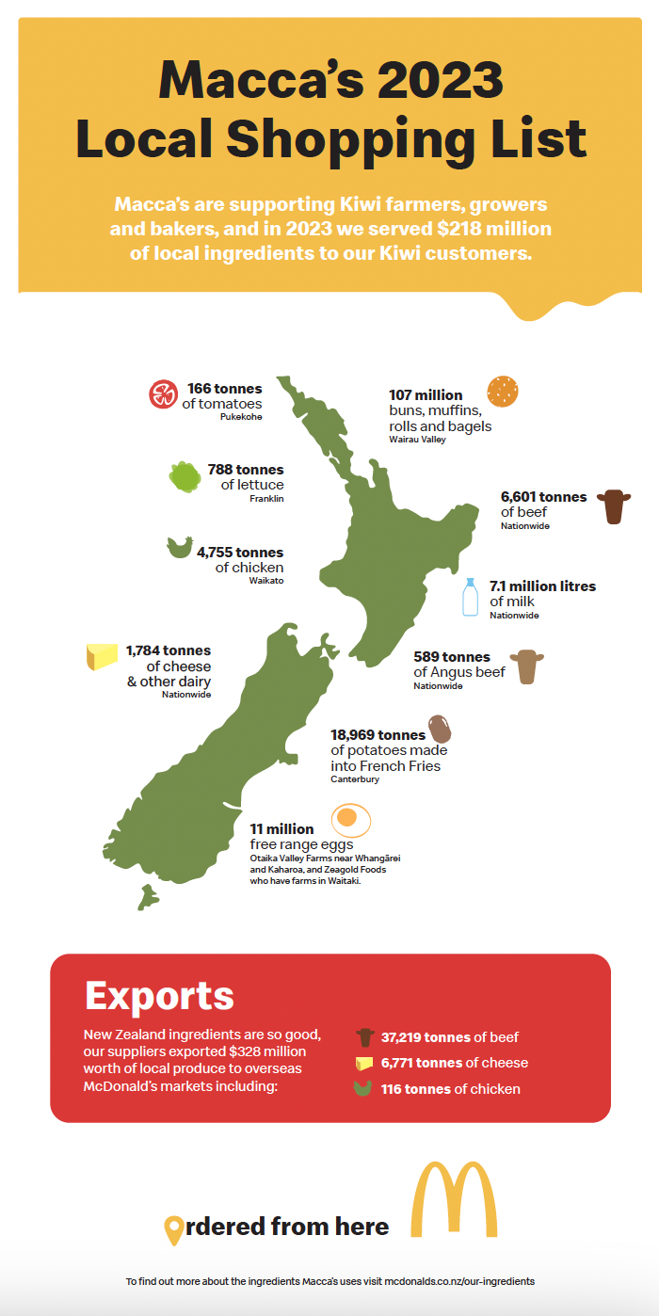

To find out more about the ingredients Macca’s uses, visit [mcdonalds.co.nz/our-ingredients](https://mcdonalds.co.nz/our-ingredients).

**ENDS**

**For more information please contact:**

Mango Communications

Jaimee Sewell | Senior Account Manager

[jaimees@thisismango.co.nz](mailto:jaimees@thisismango.co.nz) | 027 444 2166

**About McDonald’s New Zealand**

New Zealand’s first McDonald’s restaurant opened in Porirua in 1976.  Today there are over 170 McDonald’s restaurants across New Zealand, 85 per cent of which are owned and operated by locals.  The organisation employs over 11,000 people in restaurants nationwide and is one of New Zealand’s largest employers of youth. In 2023, McDonald’s spent more than $218 million with local suppliers, while New Zealand producers exported $328 million of food to other McDonald’s markets around the world. McDonald’s is the primary supporter of Ronald McDonald House Charities New Zealand, who keep families close while their children are in hospital.

For more information visit [www.mcdonalds.co.nz](http://www.mcdonalds.co.nz)

Check out McDonald’s New Zealand on Facebook [facebook.co.nz/mcdonaldsnz](http://www.facebook.co.nz/mcdonaldsnz), Instagram <http://www.instagram.com/mcdonaldsnz/> or Snapchat mcdonalds_nz